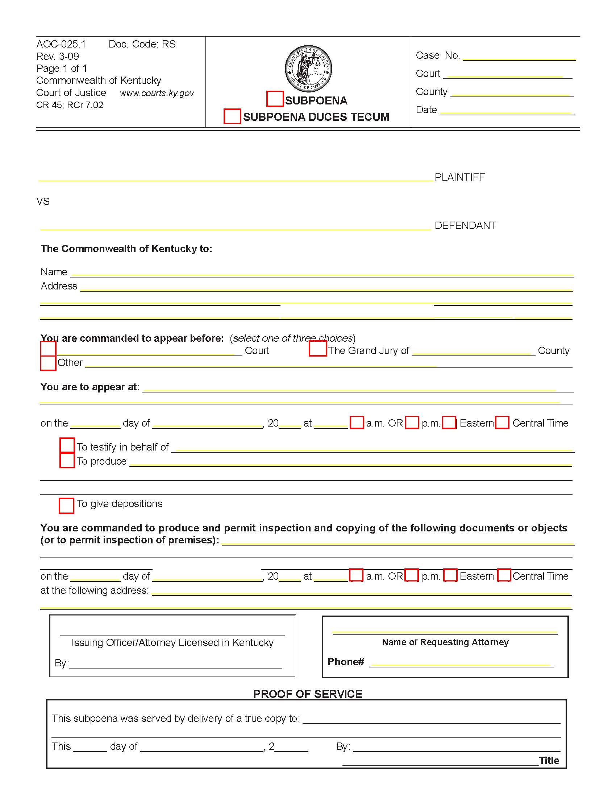
99-99999
Circuit

X
X
X
X
X
FROM 01/01/1979 TO PRESENT: Any and all MEDICAL RECORDS, including but not limited to patient history form(s), reports, etc. pertaining to Batman SSN: xxx-xx-5555, DOB: 01/01/1979.

Batman
Gotham City
University of Michigan Hospital and Health Center Release of Information Unit
2901 Hubbard Street Ann Arbor, MI 48109-0000
Axiom Requisition, 2869 Jolly Road Okemos, MI 48864 or records@axiomcopy.com
(123) 456-7890
8:00
03/15/2016
John Doe

